|  |
| --- |
|  |
|  |

***Note:*** *The Mac version of PowerPoint uses slightly different steps to those shown below. The appearance of the screens may also vary a little. PowerPoint online can be used to get past some of the limitations of the Mac version. A bit of trial and error should get you through.*

***Aim:*** *To learn about the kiosk functions in PowerPoint.*

**Appendix 2 – PowerPoint Kiosk Functions**

A2

The Interactive

Kiosk Project



Hopefully you have used PowerPoint in the past and know a bit about how to set up slides with images and text. We are going to create slides as normal, but look at how to add buttons which can be clicked or tapped in order to move to any other slide in the presentation. These buttons will give your users choices and make your kiosk interface interactive.

***Note:***  *If you need guidance getting started in PowerPoint, then our* ***PowerPoint Basics*** *and* ***PowerPoint Standards*** *will help. Your school might have purchased these resources separately.*

#### Task 1 – Action Buttons in PowerPoint

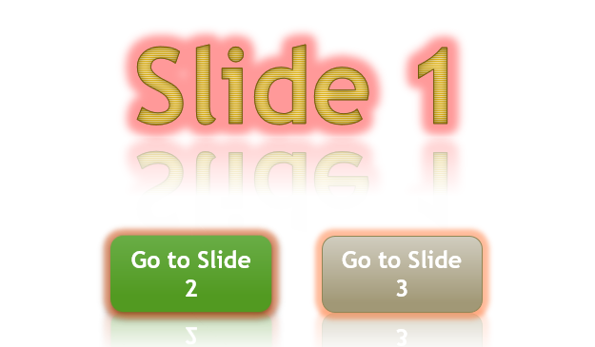We will use Action Buttons to move between the slides of our PowerPoint. Unfortunately, Action Buttons cannot be created in the online version of PowerPoint so these will need to be put in place in the PC or Mac software.

At this point, you will just be learning skills in a test presentation. You should work individually so that all members of your group learn how to set up this functionality.

1. 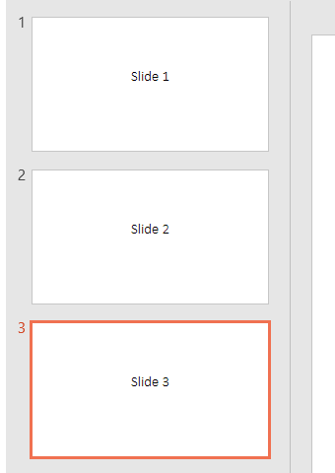Open PowerPoint on your PC or Mac. Remember that for this task, you must use the application on your computer and not the online version in your web browser. The PowerPoint software is installed on most school computers.

1. Start a new blank presentation and change the title text to ‘Slide 1’.
2. Insert a second slide (a *Title Slide* is fine) and change the title to ‘Slide 2’. Do the same again for ‘Slide 3’.
3. 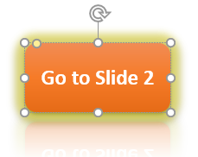Return to slide 1 and click ‘Insert / Shapes / Rectangle: Rounded Corners’. Draw a rectangle on the slide. This rectangle will become a button.

1. With the shape selected, open the ‘Format’ tab and choose a colour and design for your button. Try some of the *Shape Styles* and *Shape Effects*.

1. 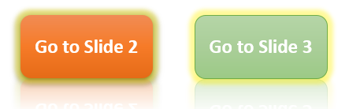Right-click on the shape and select ‘Edit Text’ from the context menu (or simply clicking on the centre of the shape usually works). Type ‘Go to Slide 2’ and format the text.

1. Copy and paste the shape, changing the colour of the new button and the text to ‘Go to Slide 3’.

|  |
| --- |
| **PowerPoint Kiosk Functions (page 2)** |

1. 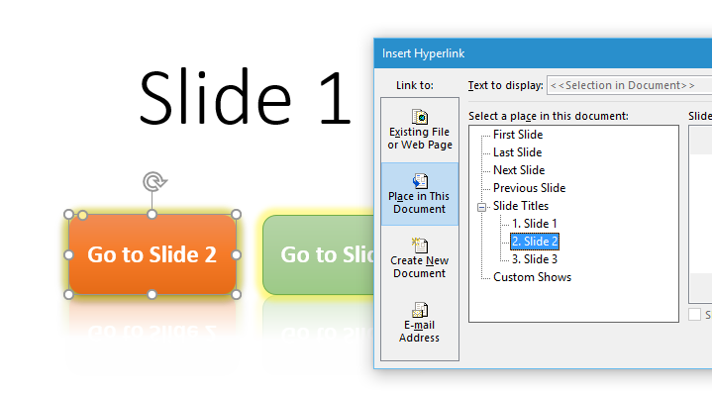Right-click on your first button and select ‘Hyperlink’ from the context menu (or click ‘Insert / Hyperlink’ in the ribbon).

1. Select the ‘Place in This Document’ option from the menu on the left and select ‘*2. Slide 2*’ from the list. Click ‘OK’.
2. Repeat this for the second button, sending the user to Slide 3.

1. View the slideshow by selecting ‘Slideshow / From Beginning’. Click on the ‘Go to Slide 3’ button. You should be taken directly to Slide 3.
2. For the moment, there are no buttons in place to move back to Slide 1. Right-click on the screen and select ‘Last Viewed’ to return to your first slide (or use the left arrow key).
3. Test the other button and press the *Escape* key to exit your presentation and return to the editor.
4. 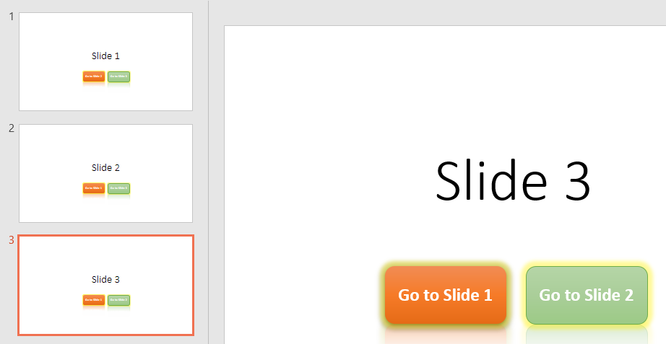Copy and paste the buttons into your other two slides. Edit the text and hyperlinks. When in presentation mode, you should be able to move from any slide to any other slide by clicking the buttons.

1. Save your work as part of your documentary record.

#### Task 2 – Design Themes

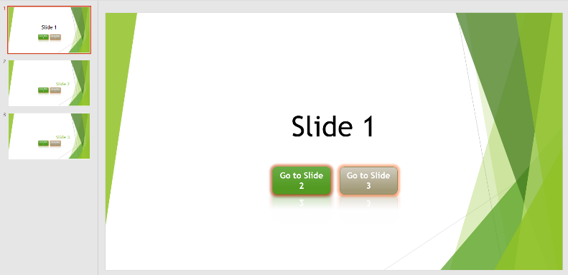Open the ‘Design’ tab in the ribbon and click on some of the different themes. You should notice that although you see some professional looking slides, everything gets shifted around and your text and formats are changed. Can you imagine this sort of thing happening once you have put 40 slides in place? It would be a lot of extra work tidying up. For this reason, we will be making design decisions before going too far with the project.

|  |
| --- |
| **PowerPoint Kiosk Functions (page 3)** |

#### Task 3 - Browsed at a Kiosk

There is an option to fix your presentation as ‘Browsed at a kiosk’. With this setup, most menus and keyboard functions are blocked, so the user is unable to access the computer for other purposes. The presentation will continue to run until the *Escape* key is pressed. However, as your kiosk won’t be making a keyboard available, the user will only be able to navigate using the Action Buttons provided.

1. Start your slideshow as normal and try doing the following things:

* Click the *right* and *left* buttons on your mouse;
* Press the *arrow* keys on your keyboard;
* Press the *Backspace* key, the *Space Bar* and the *Escape* key;
* Click anywhere on the screen that is not a button.

You should find that all these actions have an effect on the presentation. This is not good for a kiosk.

1. Back in the editor, click on ‘Slide Show / Set Up Slide Show’. Select ‘Browsed at a kiosk (full screen)’ from the ‘Show type’ options and click ‘OK’.
2. Start the presentation again and try all the actions above. You should find the only thing that has an effect is the *Escape* key. The presentation must be navigated using the Action Buttons. In a real kiosk, these buttons would be activated using a touch screen.
3. When working on your actual kiosk interface, you are better off leaving the presentation in normal viewing mode (‘Presented by a speaker’) unless you are testing the final appearance.

#### Task 4 – PowerPoint Online Limitations

As mentioned previously, there are some things that you cannot do when collaborating in PowerPoint online. Unfortunately, one of these is to create Action Buttons (you can create the buttons but not insert the hyperlinks). Luckily, it’s easy to edit an online presentation using the desktop version of PowerPoint when necessary.

1. In your browser, navigate to [office.microsoft.com/online/](http://www.office.microsoft.com/online/) and open a new PowerPoint presentation.
2. 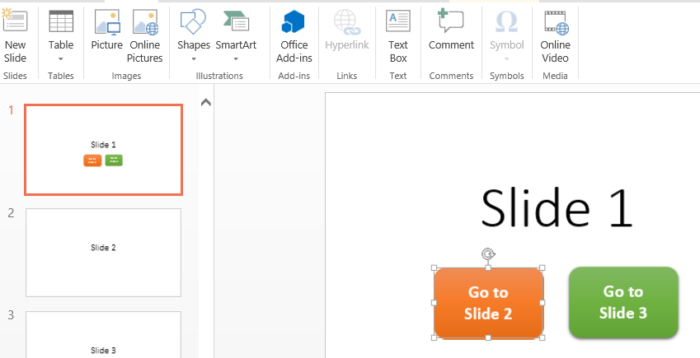Set up three slides as before and add two buttons to the first. See what formatting options you have available in PowerPoint online.
3. With one button selected, open the ‘Insert’ tab and notice that ‘Hyperlink’ is greyed out. You cannot insert a hyperlink into a shape online. You could create a hyperlink for the text placed over the top of a shape, but the result is slightly different.

1. In the bar above the ribbon, click on the ‘Edit in PowerPoint’ button. You may be warned about the file, but go ahead and open it in the application on your PC or Mac.

|  |
| --- |
| **PowerPoint Kiosk Functions (page 4)** |

1. 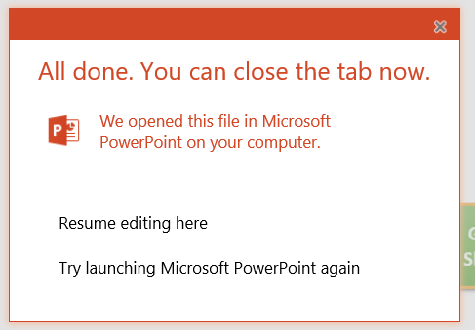Move to your desktop application and put the hyperlinks in place as before. Save the file.

1. Return to your browser. You should have the option to ‘Resume editing here’. Click on this link and wait for the screen to refresh so that you can work in your saved file online again.
2. Still in your browser, click on ‘View / Slideshow’. Once the online presentation is open, test your buttons as before. Be careful with your testing, as clicking on the screen in normal mode will always move the slideshow forwards.

1. Right-click on the screen and see what options are available. Press the *Escape* key to return to your online editor.

#### IMPORTANT

Collaborating online on this project in PowerPoint will mean completing some tasks locally and some tasks online. Although this isn’t ideal, collaboration over the internet is likely to be far more difficult if using other kiosk software.

#### Task 5 – Other Useful PowerPoint Tools

Either online or in your desktop version, try inserting some SmartArt (in the ‘Insert’ tab of the ribbon). There may be designs that you would like to use for your buttons.

Image hyperlinks? Try ‘Insert / Online Pictures’ and search for a button. You can insert the image online but as before, you can only set up the hyperlink in your desktop version of the software.

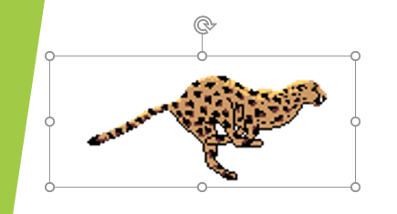

Investigate which animations are available online and in the desktop version. As before, some things can only be set up offline but will work correctly when viewed in the browser version.